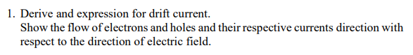

Electrons move from high → low concentration
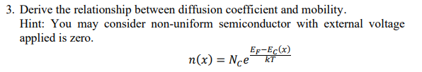
Given:
$$n(x)=N_{c}e^{\frac{E_{F}-E_{c}(x)}{kT}}$$
Since equilibrium ⇒ no net current:
$$J_{n}=0$$
Total electron current:
$$J_{n}=qnμ_{n}E+qD_{n}\frac{dn}{dx}$$
$$nμ_{n}E+D_{n}\frac{dn}{dx}=0$$
Electric field is related to conduction band:
$$E=-\frac{1}{q}\frac{dE_{c}}{dx}$$
Substitute:
$$nμ_{n}\left( − \frac{1}{q}\frac{dE_{c}}{dx}\right)+D_{n}\frac{dn}{dx}=0 \\ -\frac{μ_{n}n}{q}\frac{dE_{c}}{dx}+D_{n}\frac{dn}{dx}=0$$
Differentiate $n(x)$
$$n=N_{c}e^{\frac{E_{F}-E_{c}}{kT}}$$
Take derivative:
$$\frac{dn}{dx}=n\left(0 − \frac{1}{kT}\frac{dE_{c}}{dx}\right)$$
Substitute into current equation
$$-\frac{μ_{n}n}{q}\frac{dE_{c}}{dx}+D_{n}\left[n\left( − \frac{1}{kT}\frac{dE_{c}}{dx}\right)\right]=0$$
Factor:
$$-\frac{ndE_{c}}{dx}\left(\frac{μ_{n}}{q} + \frac{D_{n}}{kT}\right)=0$$
For non-trivial solution:
$$\boxed{\frac{D_{n}}{μ_{n}}=\frac{kT}{q}}$$
Similarly for holes:
$$\boxed{\frac{D_{p}}{μ_{p}}=\frac{kT}{q}}$$

